

Yedi Risdianto | 200511033 | TI20D

Tugas 6 : ComboBox, RadioButton, dan CheckBox

Source code ComboBox :

Public Class Form1

Private Sub Form1_Load(sender As Object, e As EventArgs) Handles MyBase.Load

cmbKodeProdi.Items.Clear()

cmbKodeProdi.Items.Add("TIF")

cmbKodeProdi.Items.Add("TIN")

cmbKodeProdi.Items.Add("TIS")

End Sub

Private Sub cmbProdi_SelectedIndexChanged(sender As Object, e As EventArgs) Handles cmbKodeProdi.SelectedIndexChanged

If cmbKodeProdi.Text = "TIF" Then

txtProdi.Text = "Teknik Informatika"

txtUKT.Text = "1500000"

txtBayar.Clear()

txtSisa.Clear()

ElseIf cmbKodeProdi.Text = "TIN" Then

txtProdi.Text = "Teknik Industri"

txtUKT.Text = "1300000"

txtBayar.Clear()

txtSisa.Clear()

ElseIf cmbKodeProdi.Text = "TIS" Then

txtProdi.Text = "Teknik Sipil"

txtUKT.Text = "1400000"

txtBayar.Clear()

txtSisa.Clear()

End If

End Sub

Private Sub txtHitung_Click(sender As Object, e As EventArgs) Handles txtHitung.Click

txtSisa.Text = Val(txtBayar.Text) - Val(txtUKT.Text)

End Sub

End Class

Hasil Program :

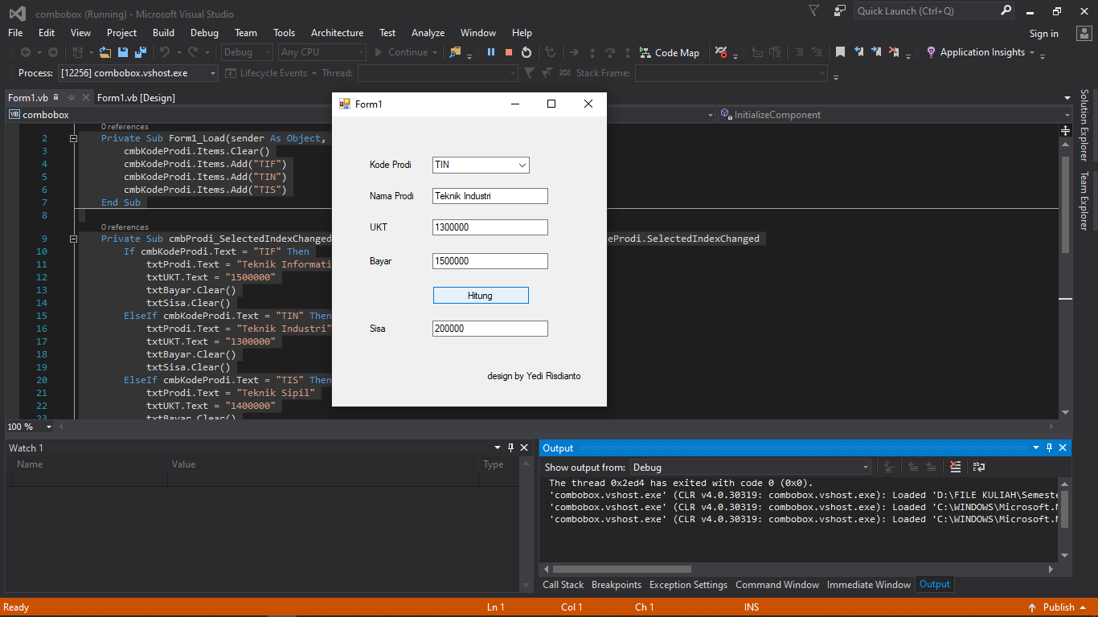

Source Code RadioButton :

Public Class Form1

Private Sub btnSubmit_Click(sender As Object, e As EventArgs) Handles btnSubmit.Click

Dim harga As Integer

'Cek kategori tiket yang dipilih

If radioAnak.Checked Then

harga = 20000 'Harga tiket anak-anak

ElseIf radioDewasa.Checked Then

harga = 30000 'Harga tiket dewasa

Else

MessageBox.Show("Pilih kategori tiket terlebih dahulu")

Exit Sub

End If

'Tampilkan harga tiket

txtHargaTiket.Text = harga.ToString

End Sub

End Class

Hasil Program RadioButton :

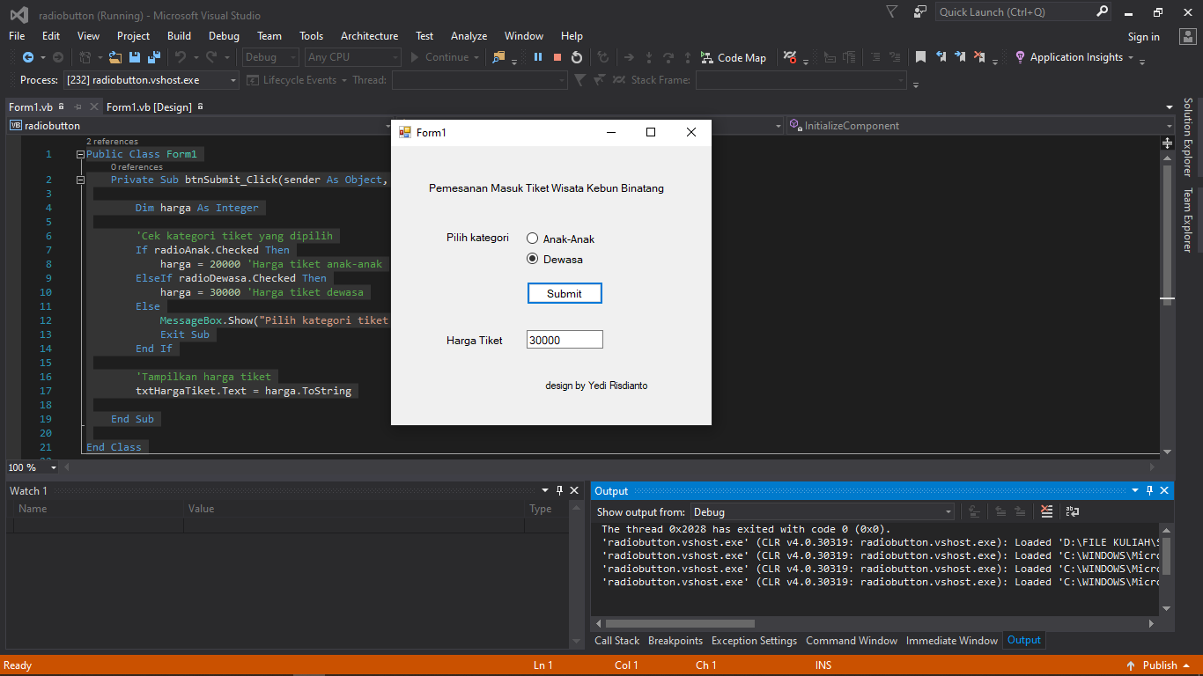

Source Code CheckBox ;

Public Class Form1

Private Sub btnHitung_Click(sender As Object, e As EventArgs) Handles btnHitung.Click

Dim hargaBarang As Double

Dim jumlahBarang As Integer

Dim totalbyr As Double

hargaBarang = CDbl(txtHarga.Text)

jumlahBarang = CInt(txtJumlah.Text)

totalbyr = hargaBarang * jumlahBarang

If checkMember.Checked Then

totalbyr *= 0.9 'diskon 10% untuk anggota

End If

txtTotal.Text = Format(totalbyr, "N0")

End Sub

End Class

Hasil Program CheckBox ;

